Velomobile Control & Telemetry System QA Process Description

Version 1.0

Revision History

|  |  |  |  |
| --- | --- | --- | --- |
| **Date** | **Ver.** | **Description** | **Author** |
| March 12, 2010 | 1.0 | Initial Composition | Daniel Johnson |

Table of Contents

1. Introduction 4

1.1 Purpose 4

1.2 Quality Assurance Standards 4

1.3 Quality Assurance Process Diagram 4

2. Process Description 5

2.1 Requirements 5

2.2 Design 5

2.3 Construction 6

2.4 Deployment 6

2.5 Quality Assurance and Testing 6

# Introduction

## Purpose

This document is intended to explain the Quality Assurance and development process. It will cover our general process with a diagram and description of the general process and individual steps. Interested readers may evaluate an example of our development process by examining our project log located in our Quality Assurance and Project Log folder.

## Quality Assurance Standards

Our quality assurance standards are intended to make sure our system is of the appropriate quality for the deployment we are working towards. We determine the quality of work by first evaluating the deployment we are aiming to reach. Fast deployments for proofs of concept or in-house demonstration will have lower quality standards than for example deployment of an alpha prototype. The general rules behind our quality assurance standards however are this; does the system meet requirements necessary for deployment and does the system have no system breaking errors and handle remaining errors? If so, then the system will pass our quality assurance standards.

## Quality Assurance Process Diagram

Our quality assurance diagram is very similar to the typical software diagram, except we have combined quality assurance and testing into one, as we feel throughout the entire project we are testing components we are designing or technologies that will be implemented in the system.

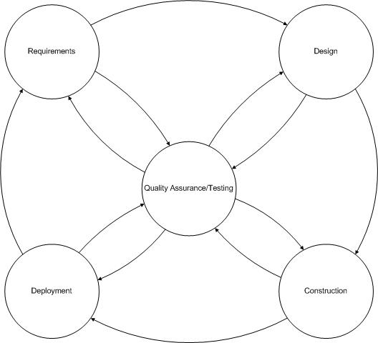

Figure 1.1: Quality Assurance Diagram

# Process Description

In this section will cover a breakdown of each element in our quality assurance process and their relationships to the process as a whole. Our starting point in this process is requirements, the initial phase of gathering system requirements and use cases which we then turn over to design. We’ll first start with Requirements then work our way around the circle, covering our quality assurance and testing stage last.

## Requirements

The requirements stage is the initial stage of development where the team studies and begins to understand the system we are developing and the problems we need to solve. This initially starts with requirements of what the system will do, providing a contract to work off of. We then take those requirements and begin creating use cases associating requirements to use cases and creating additional requirements as we go. We also begin testing technologies so as to identify possible technologies to use in the system.

## Design

This phase is one of the most challenging phases as we often have to revisit our requirements and make updates to our requirements and use cases. At this stage we continue to test technologies and verify what technologies will be used in the system. At this stage we begin to develop our logical architecture describing system design and interface. Other modeling like component, use case, and sequence diagrams are also generated in this phase for use in the construction phase. Technologies that need to be purchased or ordered are now requested for construction of the system.

## Construction

Now development of the system begins for code generation and component assembly. In this stage we often need to revisit our quality assurance and testing stage to verify our systems output and maintain project artifacts like requirements and diagrams relating to the code being written. Often our diagrams make major shifts here, but we usually are able to maintain most interfaces and class definitions. Once development is complete and we have passed off our developed system components to quality assurance and testing we prepare for deployment.

## Deployment

Once we are to the deployment phase we pass off the system components to be deployed one last time to quality assurance and testing to verify that the system meets our quality assurance standards and meets requirements we are aiming to fulfill in this deployment. Once deployed we once again move on to the requirements stage to re-evaluate our requirements.

## Quality Assurance and Testing

This is the key component to our system that provides us with an agile development approach to our system development. This stage verifies that system components are meeting our quality assurance standards (as described above in section 1.2) and also verifies that our system is functional and meeting our established requirements.